Name : Soumya Dixit
Batch : B2 Sem : 5
PRN : 23070521151

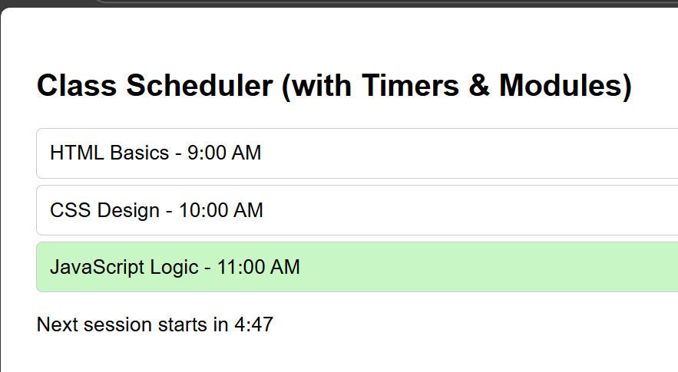

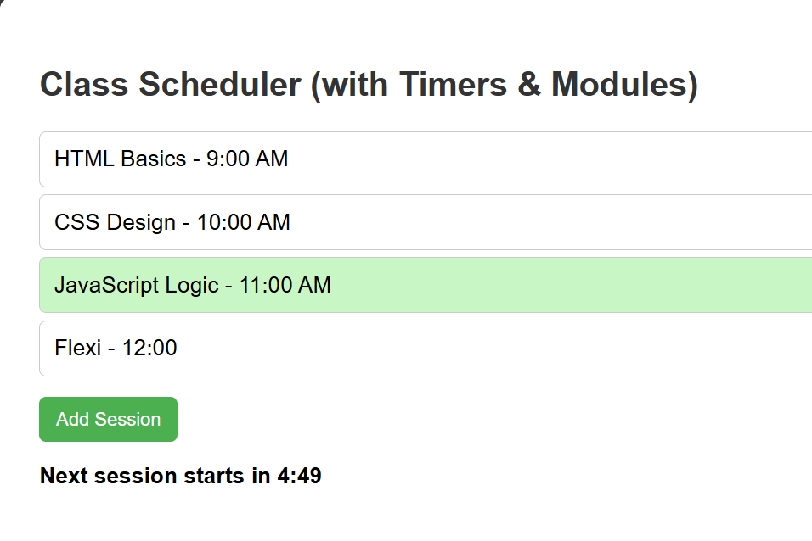

index.html

<!DOCTYPE html>
<html lang="en">
<head>
<meta charset="UTF-8">
<title>Timers, Dynamic UI & Modular Design</title>
<style>
body {
font-family: Arial;
padding: 20px;
transition: background 0.3s, font-size 0.3s;
}

h2 { color: #333; }

.session {
padding: 10px;
margin: 5px 0;
border: 1px solid #ccc;
border-radius: 5px;
cursor: pointer;
}

.active {
background: #c8f7c5;
}

/* Countdown styling */
#countdown {
font-weight: bold;
margin-top: 15px;
}

/* Task 4: Responsive font size when width < 500px */
@media (max-width: 500px) {
body { font-size: 14px; }
}

@media (min-width: 501px) {
body { font-size: 16px; }
}

button {
margin-top: 10px;
padding: 8px 12px;
border: none;
border-radius: 5px;
background: #4CAF50;
color: white;
cursor: pointer;
}

button:hover {
background: #45a049;
}
</style>
</head>
<body>
<h2>Class Scheduler (with Timers & Modules)</h2>

<!-- Container for sessions -->
<div id="sessions">
<div class="session" data-time="09:00">HTML Basics - 9:00 AM</div>
<div class="session" data-time="10:00">CSS Design - 10:00 AM</div>
<div class="session" data-time="11:00">JavaScript Logic - 11:00 AM</div>
</div>

<!-- Task 1: Add Session Button -->
<button id="addSessionBtn">Add Session</button>

<!-- Countdown display -->
<p id="countdown"></p>

<!-- Main JS (module) -->
<script type="module" src="main.js"></script>
</body>
</html>

timer.js

// timer.js — handles countdown timer and active session highlighting
import { formatTime, logEvent } from './helper.js';

// Function to start countdown timer
export function startCountdown(duration, display) {
let time = duration;

const timer = setInterval(() => {
const minutes = Math.floor(time / 60);
const seconds = time % 60;

// Task 2: Change color when time < 1 minute
if (time < 60) {
display.style.color = "red";
} else {
display.style.color = "black";
}

display.textContent = `Next session starts in ${formatTime(minutes, seconds)}`;
time--;

if (time < 0) {
clearInterval(timer);
display.textContent = "Session Started!";
logEvent("Countdown ended.");
}
}, 1000);
}

// Highlight currently active session
export function highlightActiveSession() {
const sessions = document.querySelectorAll('.session');
const now = new Date();
const currentHour = now.getHours();

sessions.forEach(session => {
const hour = parseInt(session.dataset.time.split(':')[0]);
if (hour === currentHour) {
session.classList.add('active');
logEvent(`Highlighted active session: ${session.textContent}`);
} else {
session.classList.remove('active');
}
});
}

ui.js

// ui.js — manages dynamic UI and responsiveness
import { logEvent } from './helper.js';

// Change background based on viewport size
export function handleViewportChange() {
if (window.innerWidth < 600) {
document.body.style.background = '#f0f8ff';
} else {
document.body.style.background = 'white';
}

// Task 4: Font size responsiveness handled via CSS @media queries
}

// Add event delegation for dynamic behavior
export function addDynamicSessions() {
const sessionsDiv = document.getElementById('sessions');

sessionsDiv.addEventListener('click', (e) => {
if (e.target.classList.contains('session')) {
alert("You selected: " + e.target.textContent);
logEvent(`Clicked on: ${e.target.textContent}`);
}
});
}

// Task 1: Add new session dynamically using a button
export function setupAddSessionButton() {
const button = document.getElementById('addSessionBtn');
const sessionsDiv = document.getElementById('sessions');

button.addEventListener('click', () => {
const time = prompt("Enter session time (HH:MM):", "12:00");
const title = prompt("Enter session title:", "New Session");

if (time && title) {
const newDiv = document.createElement('div');
newDiv.classList.add('session');
newDiv.dataset.time = time;
newDiv.textContent = `${title} - ${time}`;
sessionsDiv.appendChild(newDiv);
logEvent(`Added new session: ${title} at ${time}`);
}
});
}

helper.js

// helper.js — Task 3: Separate helper module for formatting & logging

// Format minutes and seconds as MM:SS
export function formatTime(minutes, seconds) {
return `${minutes}:${seconds < 10 ? '0' + seconds : seconds}`;
}

// Log helper to console with timestamp
export function logEvent(message) {
const now = new Date();
console.log(`[${now.toLocaleTimeString()}] ${message}`);
}

main.js

// main.js — main controller file
import { startCountdown, highlightActiveSession } from './timer.js';
import { handleViewportChange, addDynamicSessions, setupAddSessionButton } from './ui.js';

// Select the countdown display
const countdownDisplay = document.getElementById('countdown');

// Start countdown (5 minutes = 300s)
startCountdown(300, countdownDisplay);

// Highlight active session every minute
setInterval(highlightActiveSession, 60000);
highlightActiveSession(); // Run immediately on load

// Handle responsive behavior
window.addEventListener('resize', handleViewportChange);
handleViewportChange();

// Enable event delegation
addDynamicSessions();

// Task 1: Initialize "Add Session" button functionality
setupAddSessionButton();

